Problem-15
Problem Definition: Integrate all modules into a single deployable StudentHub portal. Verify navigation, responsiveness, authentication, database operations, security checks, AJAX functionality, and documentation. Deploy locally using XAMPP/Apache virtual host and submit GitHub repository.

Project Integration
All implemented practical modules were integrated into the StudentHub portal.
The portal includes:
- User registration and login
- Authentication and session management
- Role-based access for administrators and students
- Student record management
- Event management
- Fetch API functionality
- College Events page
- Semester Results page
- Help & Support page
- Administrator dashboard
- Audit logging

Testing and Verification:

Sr. No. | Test Case | Expected Result | Status
1 | Navigation Links | Pages open correctly | Passed
2 | Administrator login | Administrator dashboard opens | Passed
3 | Student login | Student dashboard opens | Passed
4 | Logout | User session ends | Passed
5 | Student management | Add, view, edit, and delete operations work | Passed
6 | Event management | Events can be managed | Passed
7 | College Events page | Event data loads correctly | Passed
8 | Semester Results page | Result data loads correctly | Passed
9 | Help & Support page | FAQs load correctly | Passed
10 | Responsive design | Layout adapts to different screen sizes | Verified by inspection
11 | Database operations | Application communicates with MySQL | Passed
12 | Local virtual host | Application opens using  http://studenthub.local | Passed

Security Verification
The following security measures were reviewed in the project:
- Password hashing and verification
- Prepared statements for database queries
- Session management and timeout handling
- Server-side role-based authorization
- Output escaping to reduce cross-site scripting risks
- Validation of uploaded files
- Protection of sensitive configuration and user data
AJAX and Fetch API Verification
The Fetch API functionality was implemented in JavaScript for the following pages:
- College Events
- Semester Results
- Help & Support
The JavaScript handles data loading and includes appropriate loading indicators, error handling, and empty-result handling.

Local Deployment Using Apache Virtual Host
Project location:
C:\xampp\htdocs\StudentHub
Local application URL:
http://studenthub.local

Output:

Home Page:
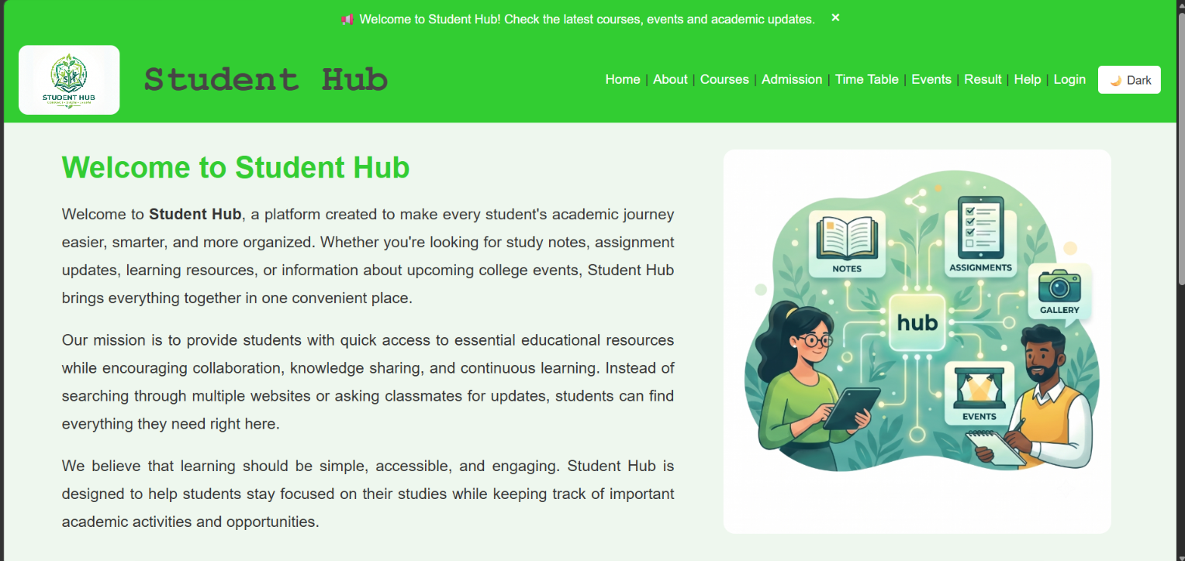

Administrator dashboard: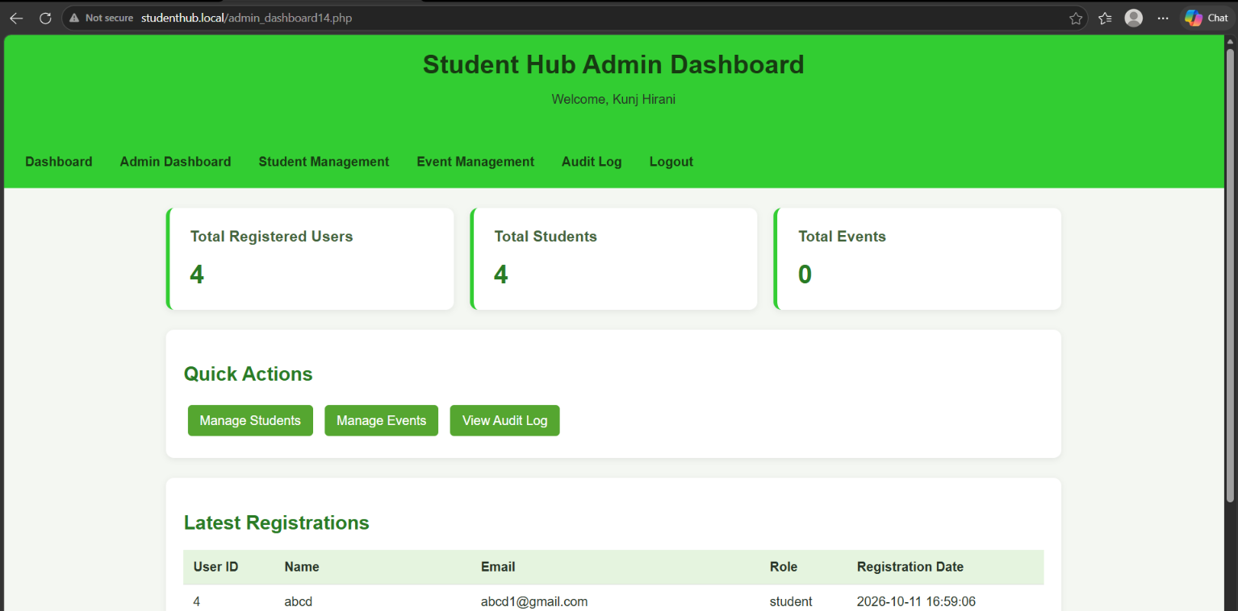

Student Dashboard: 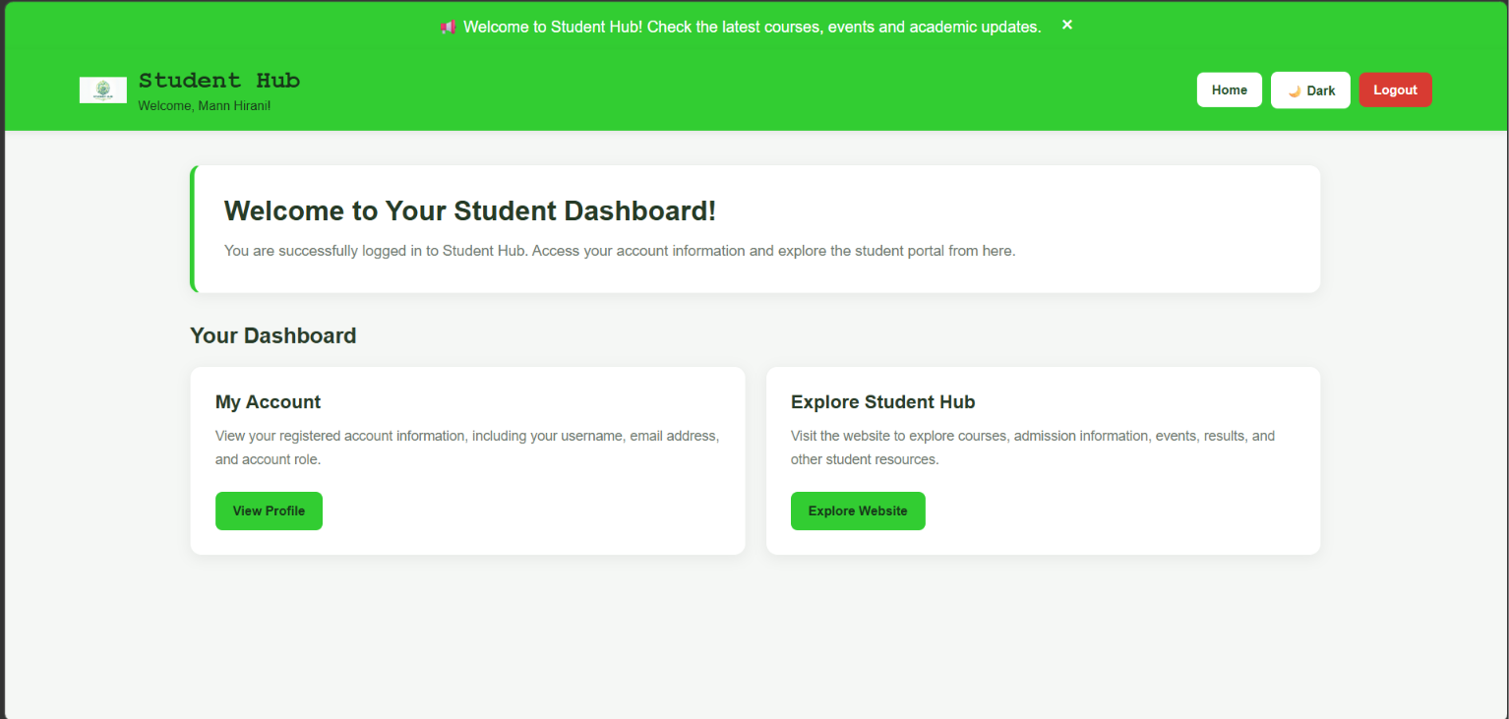

Student management page: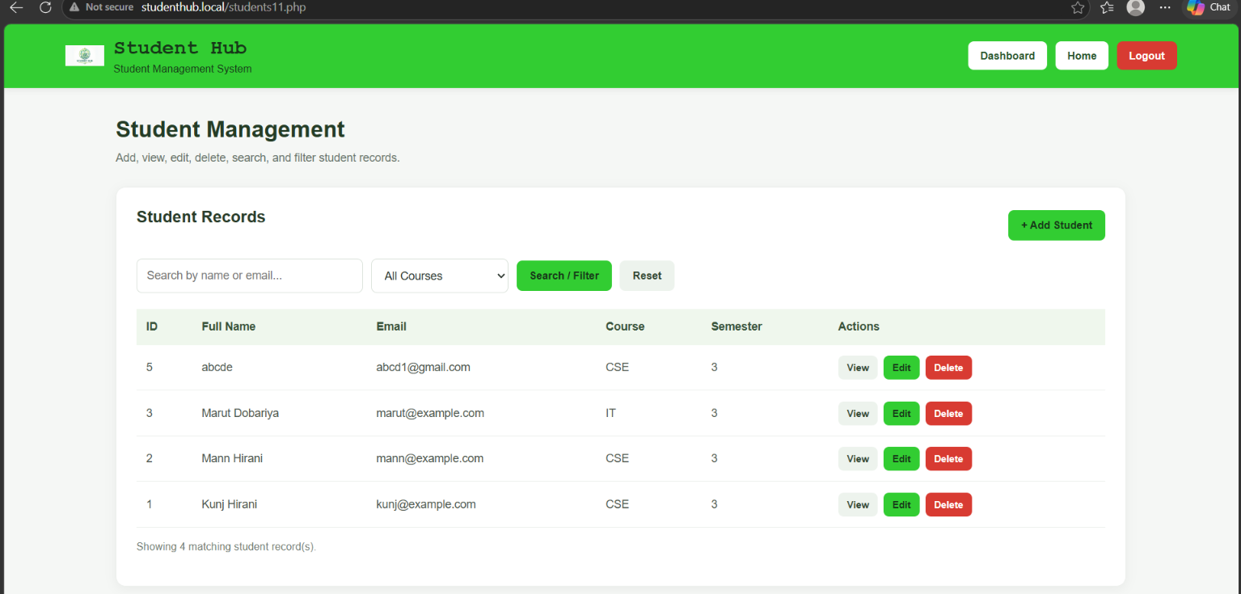
Event management page: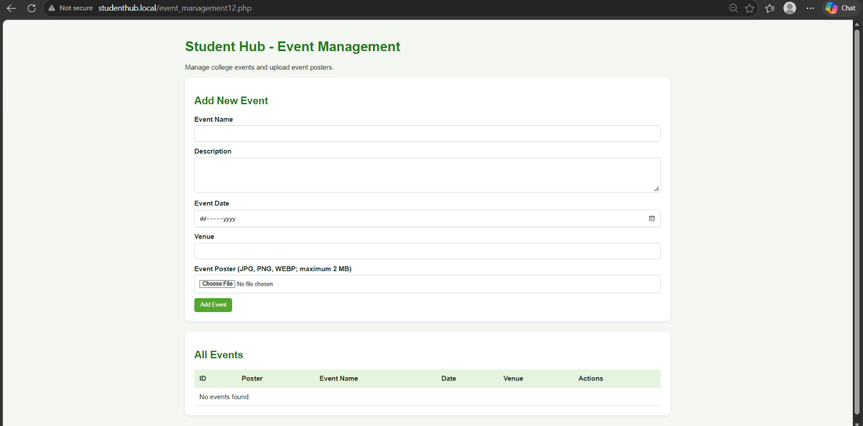

College events page: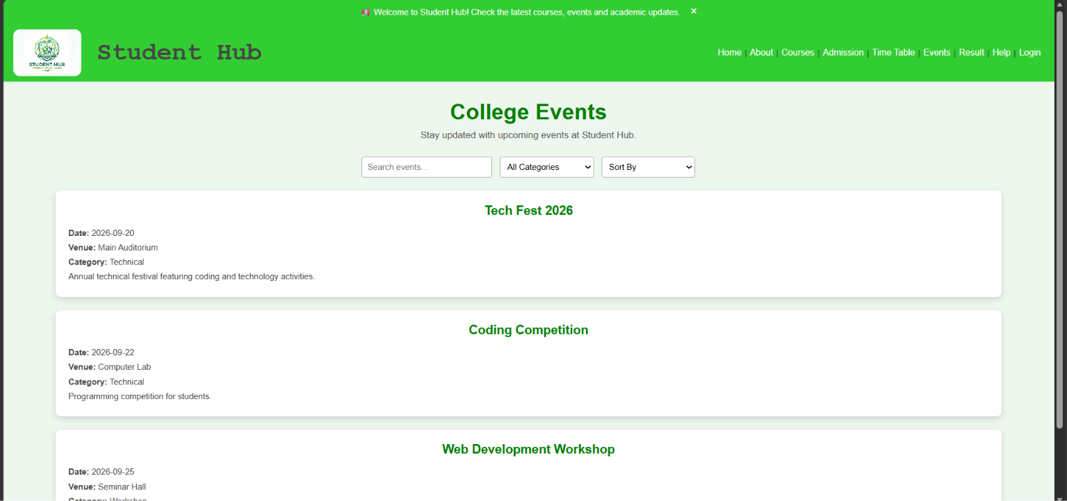
Semester results page: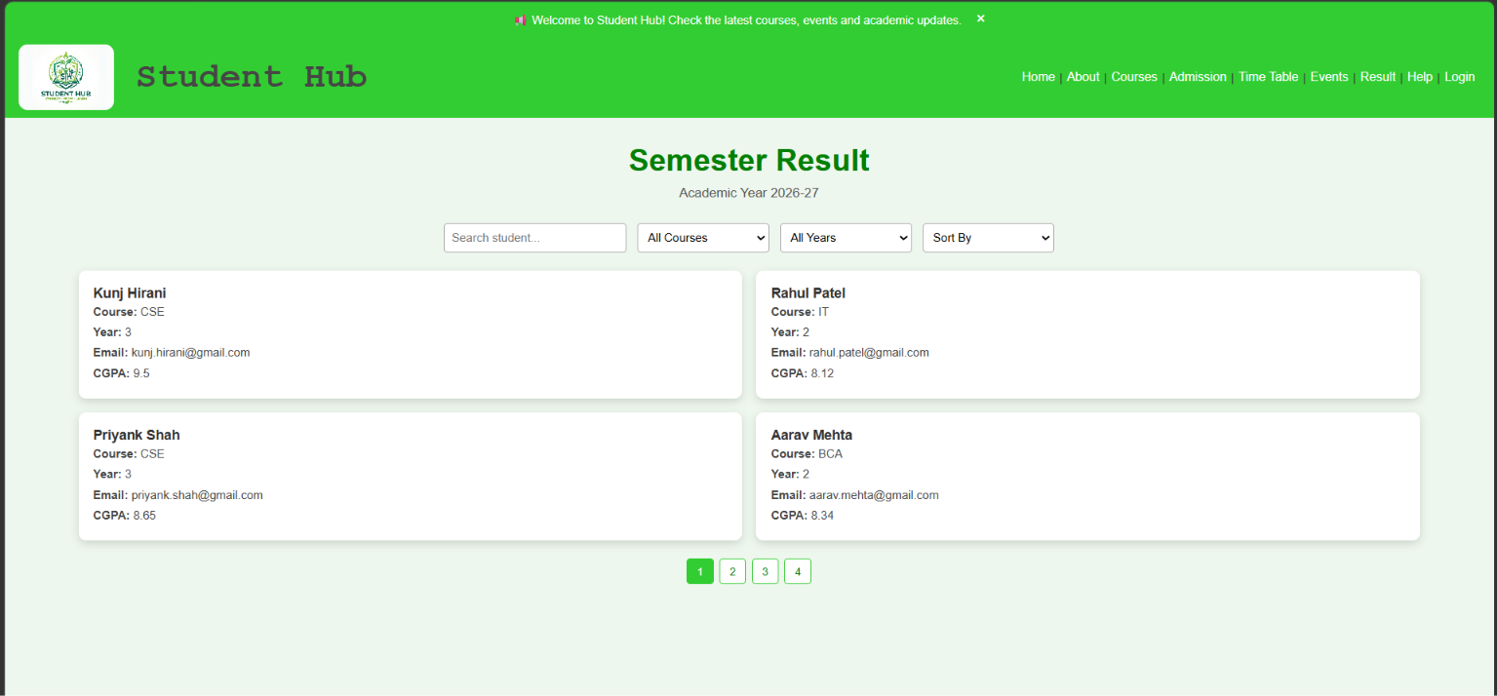

Help and support page: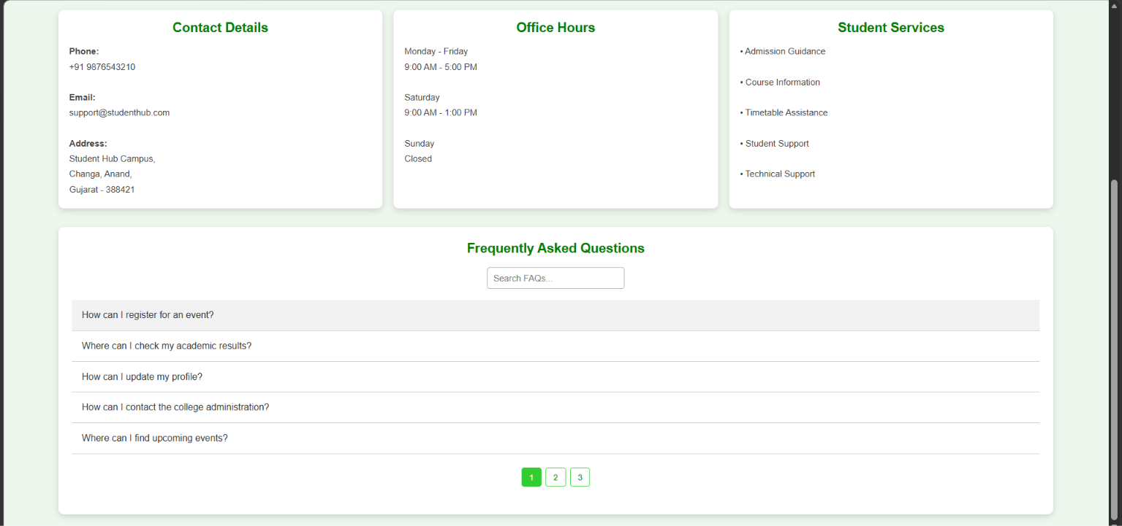
XAMPP control panel: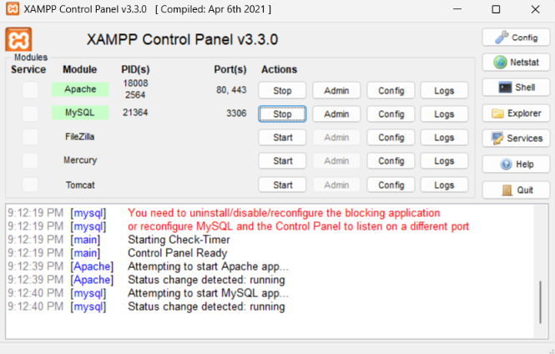

Github link:
https://github.com/kahanipatel156-dev/WDF-Batch-B/upload/main/Practical%2015

